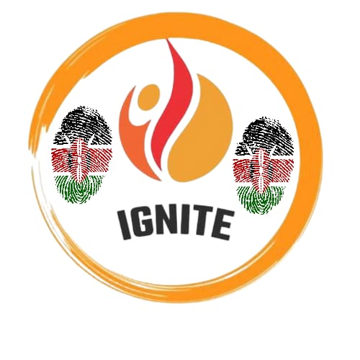
IGNITE KENYA-
Inspire | Inspire | Imagine
Grow | Go | Gather
Network | Now | Next
Impact | Involve | Initiate
Transform | Try | Team
Empower | Energize | Evolve

TAG LINES
- Youth on fire for change
- Spark your potential
- Igniting hope building tomorrow
- Unleash your inner flame
ABOUT - IGNITE Kenya is a nonprofit organization dedicated to harnessing the power of artistic expression to promote meaningful youth participation in decision-making spheres. We believe that art whether visual, performing, or digital provides a compelling platform for young people to communicate ideas, challenge norms, and advocate for change. Our programs nurture leadership, critical thinking, and civic engagement through workshops, exhibitions, advocacy campaigns, and public dialogues.
IGNITE KENYA was registered under the department of social services in 2022. It is a youth-led community based organization that operates within Nakuru County with a keen focus on youths from informal settlements. IGNITE targets youths from the age of 5 – 29 years.
MISSION - Empowering young people through art to actively engage and influence decision-making processes in their communities, ensuring their voices are heard and valued.
VISSION- A society where creativity shapes policies and social change, fostering inclusive, transparent, and effective governance.
THEMATIC AREAS
- Youth empowerment
- Social justice
- Wellness

CORE-VALUES
- Creativity- encouraging innovative artistic expression as a tool for youth voices to be heard
- Empowerment – supporting youth to take ownership of their ideas and actively participating in shaping communities.
- Social impact – using art intentionally to raise awareness, inspire change, and advocate for issues that matter to young people.
- Collaboration – building partnerships among youth and other stakeholders to strengthen collective influence.
- Integrity – acting honestly and transparently, ensuring youth participation is genuine and meaningful rather than symbolic.

PROGRAMS
- Art for Change Workshops: Facilitating participatory art projects that foster critical discussions on social and political issues.
- Youth Leadership Labs: Training young leaders to use art-based strategies to influence policy and community planning.
- Public Exhibition Series: Showcasing youth artwork linked to local decision-making topics, inviting public and official engagement.
- Advocacy Campaigns: Partnering with youth to design multimedia art campaigns that highlight key policy concerns.
- School programs- establishing leadership clubs in high schools in Nakuru. This will be an extension of IGNITE in local schools. The” leading self “module will be used to facilitate dialogues in all schools.

SERVICES
- Membership and subscription fees- offering membership packages for youth participants, alumni, or supporters that include exclusive access to events, training or merchandise.
- Merchandise sales- selling branded skate gear, apparel, or creative works by youth participants.
- Events – selling tickets for fundraising events such skating competitions, community skating days or benefit galas.
IMPACT GOALS
- Increase youth representation in local decision making forums by 30% within five years.
- Engage over 1000 young participants annually in creative civic engagement activities.
- Influence budget adoptions for youth empowerment programs

KEY ACHIEVEMENTS
CORE-VALUES
- Youth-Centered: Prioritize the perspectives and leadership of young people.
- Creativity as Catalyst: Use art to spark dialogue and inspire action.
- Inclusivity: Ensure access and representation for marginalized and diverse youth.
- Collaboration: Work with partners across sectors to amplify impact.
- Transparency: Operate with openness and accountability

CONTACT INFORMATION

APPROACH\STRATEGY\PARTNERSHIP\TEAM\FUTURE GOALS-

